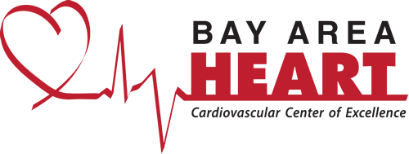

Vein SCREENING ASSESSMENT

Name: |  | Date Of Birth:
Primary Insurance: |  | Secondary Insurance:
Sex M F | Date of Birth: | How did you hear about us?

HISTORY

Have you ever had varicose veins or bulging veins? Yes No

SIGNS AND SYMPTOMS

Do you experience any of the following in your legs or ankles?

Leg pain, aching or cramping
Burning or itching of the skin
Leg or ankle swelling, especially at the end of the day
“Heavy” feeling in legs
Varicose veins
Skin discoloration or texture changes, such as above the inner ankle
Open wounds or sores, such as above the inner ankle
Restless legs

RISK FACTORS

Has anyone in your family ever had varicose veins? Yes No

Have you had any treatments or procedures for vein problems? Yes No

Do you sit or stand for long periods of time, such as at work? Yes No

Do you frequently engage in heavy lifting? Yes No

Have you ever had varicose veins or bulging veins? Yes No

Additional Notes

____________________________________________________________________________________________________________________________________________________________________________________________________________________________________________________________________________________________________________________________________________________________________________________________________________________________________________

_______________________________________________________ ______________________
Patient Signature Date

_______________________________________________________
Print Name

